**Logo Design Process Tutorial**

[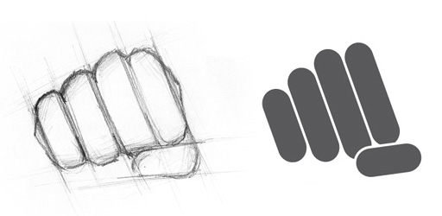](http://dryicons.com/blog/2009/02/28/logo-design-process-tutorial/)

**Introduction**

One of the main aspects of the branding process includes logo development. Your logo, or *brand mark*, in other words, needs to reflect your brand accurately, as it will play a huge role in your brand recognition. This however doesn’t mean that the branding process ends when you’ve developed your logo, branding takes a lot of time, commitment, managing skills and finally, the ability to reflect the image you want others to have of you and your business

This tutorial is intended to benefit both our potential *clients*, so they can have a fully comprehensive overview of our logo design process and methods; and many of our *users*, interested in the process of designing and developing a logo.

For the purpose of this tutorial, we’re going to design and develop a logo for an imaginary company, called “LTD”, short from Logo Tutorial by DryIcons.

**Project Start and design brief**

The project starts when we receive a detailed design brief from our (imaginary) client. This is an important part of the designing process, because it will provide us with essential information about our client’s insights, needs, expectations and targets. Understanding the nature of the project is beneficial for both designer and client, since it will save both parties a lot of valuable time (money) and will provide firm starting position which will result in a professional and effective product.

Based on our client’s information we now know that this is a strong, powerful, creative, responsible youth organization, which employs highly motivated, university educated staff. They are very passionate about what they believe in: individuality, democracy, creativity, non-conventional thinking, gutsy and dynamic attitude. Their target group consists of students, young professionals and independent entrepreneurs.

They expect us to create an easily-recognizable, stylish graphic work, which will accurately express these characteristics.

**Research**

Research will mark the second stage of the design process. This stage means spending a lot of time browsing the Internet, initially doing research of the industry involved, getting to know our client’s competition, current design trends and so on.

**Visualization**

Now this is the fun part. After we’ve gathered all the necessary knowledge, after a lot of reading and brainstorming, we are ready to start visualizing our ideas. Pencil drawing on a piece of paper is our favorite method when working on the initial concepts, however, this is just a matter of personal choice.

Knowing when to stop and take a break has proven to be very helpful at this point. It’s very easy to get stuck at a certain point, which will eventually lead to frustration and losing interest in the project. Leaving the project to rest for a while is always good, because when you get back to it, you are suddenly able to judge your work more objectively, and you instantly know which concept provides you solid ground for further development.

After the break, we have chosen one idea that will be our main concept upon which we’re going to develop the logo. We are going to use a stylized fist, a powerful symbol which will unite all aspects of this logo design project.

Another method that’s proved to be very helpful when visualizing your ideas is taking photos of your ideas, of course, when possible. With our desired symbol and perspective in mind, we have taken this photo:

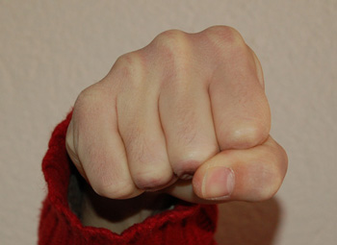

**Drawings**

Based upon the photo image, we have drawn the fist. As you can see, highlighting the fist outlines can serve as a good starting point to developing this logo, but we are instantly going to abandon this idea because this is not the path we want to take.

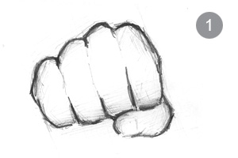

Instead, we’re looking to develop a modern, stylized, easily-recognizable symbol. Therefore, we’re continuing to explore the fist drawing, now coming up with a more simple and stylized version.

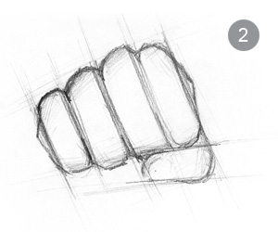

The previous sketch has guided us in the right direction, and we now have a version of the fist drawing that’s, in our opinion, very strong and memorable, but also very creative and modern.

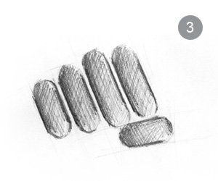

Now we can move on to our computers.

**Computer developing**

Creating the Logo Mark

From the Toolbar, choose the Rectangle Tool to draw a simple rectangle, like on the image below. With the rectangle selected, go to Effect > Stylize > Round Corners, and give the rectangle a semicircle roundness.

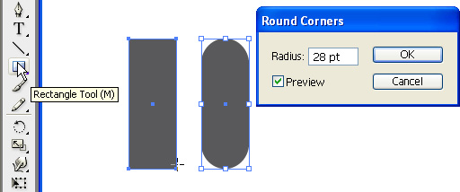

Now, copy and paste the same object. Click on the new object and slightly increase its height.

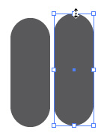

Repeat the same procedure to create all four fingers. Increase the object’s height to resemble the different size of human fingers.

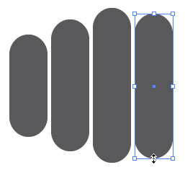

Copy and paste the smallest, pinky finger. The new object will represent the thumb. Place the thumb object accurately and rotate to the desired position.

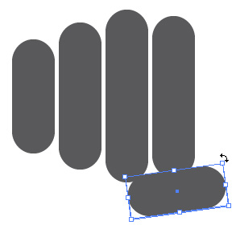

Select all four finger objects and rotate to the desired position.

To be able to use the Trim Tool later, we need to expand the object appearance. Select all objects and go to Object > Expand Appearance.

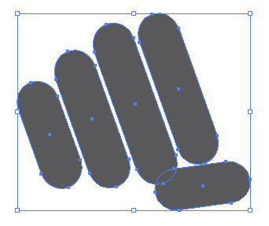

To preserve the continuity of the design, we need to separate the thumb from the fingers that are touching. First we’re going to create the thumb contour. The contour thickness needs to be the same as the spaces between the fingers. Select the thumb and go to Object > Path > Offset Path.

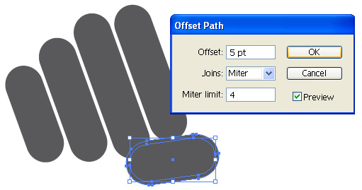

Creating the contour will automatically group the two objects together. To ungroup the contour from the thumb go to Object > Ungroup. Select the contour and change its color to have better articulacy.

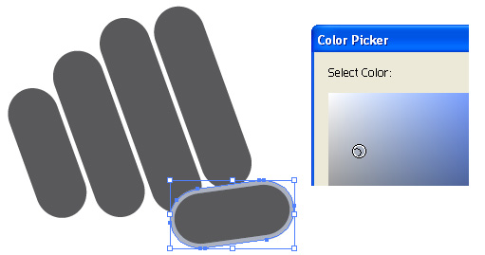

We now want to trim the two fingers with the contour. Select the contour and while holding the Shift Key we’ll select the two fingers we want to cut. Go to Window > Pathfinder to open the Pathfinder Window and click Trim.

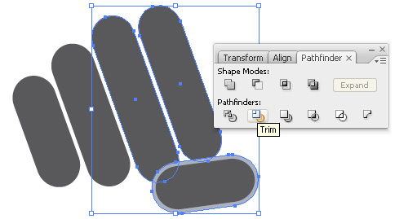

Go to Object > Ungroup to separate the grouped objects, select the contour and delete it. This is the result of this procedure.

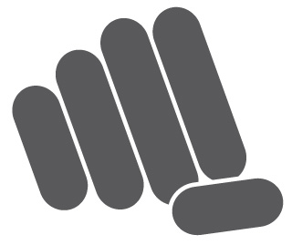

Applying the Company Name

Having our logo mark created, we now want to apply the company name. We think that the best way to do that would be to create another similar rounded object which will contain the name of the company. From the Toolbar, choose the Rectangle Tool and again draw a simple rectangle, like on the image below. With the rectangle selected, go to Effect > Stylize > Round Corners, and give the rectangle a semicircle roundness. We choose to color this object red, because this color provides good contract from the logo mark and bring more attention to the company name.

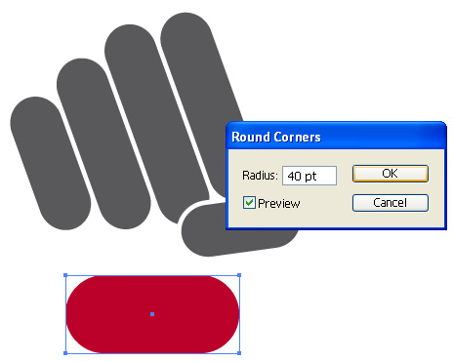

Choosing the right Typography

Choosing the right Typography is a very important part of the logo development process. The selection of font can depend on many things, like what look you are trying to convey, what’s the font’s purpose, how much space needs to be filled, and so on. Since our design uses rounded corners, and we don’t want the company name to be distracted, we have decided to use a simple font with rounded corners, but without any complex details.

For the purposes of this tutorial I’m using a font called “Arial Rounded”.  
Now, select the Type Tool, and type the word you need.

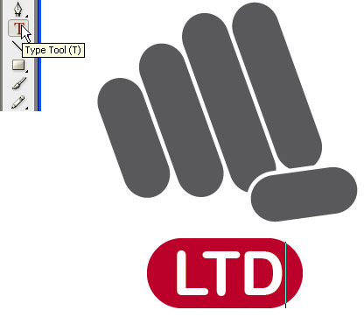

This is the final result. It’s always best to provide your clients with vector files of the artwork, because vectors can be scaled to any size without loss of quality.

On the image below you can see that we also created a grayscale and a black version of the logo. A good, strong logo shouldn’t loose its impact in the black and white version.

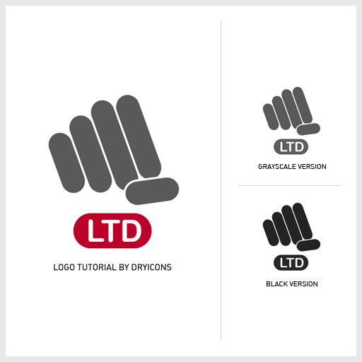

Corporate identity

Having created a good logo is one thing. Using the logo to create a recognizable Corporate Identity is as important as everything we’ve done by now in this tutorial.

In the image below you can see a great example of a consistent design and creativity and professional appeal.

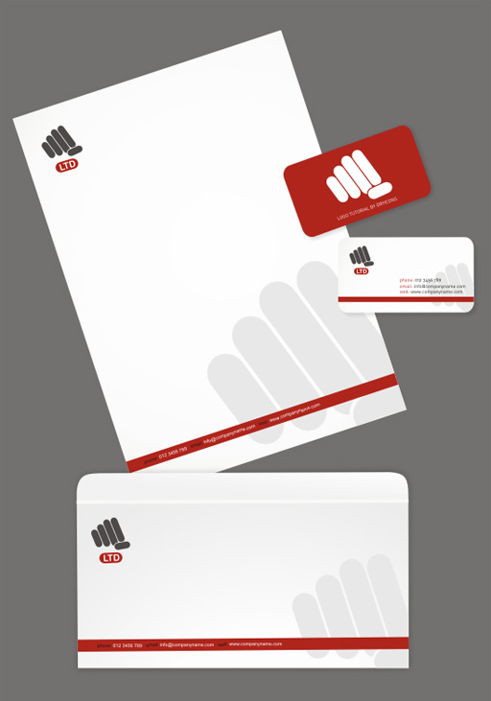

Hope you liked our Logo Design and Process Tutorial. Please share your thoughts with us on this subject, do you share similar design methods, do you find this tutorial to be helpful? And make sure to come back for more.